NETHERLANDS

Creating table sid_netherlands.

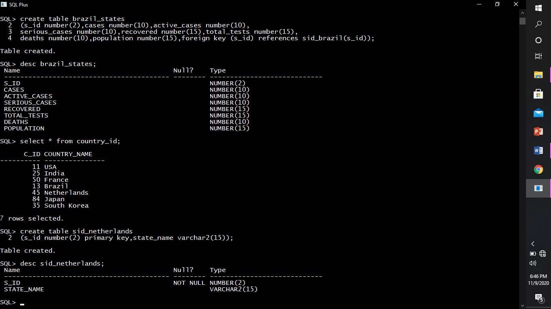

Describing structure of sid_netherlands.



Inserting rows into sid_netherlands.

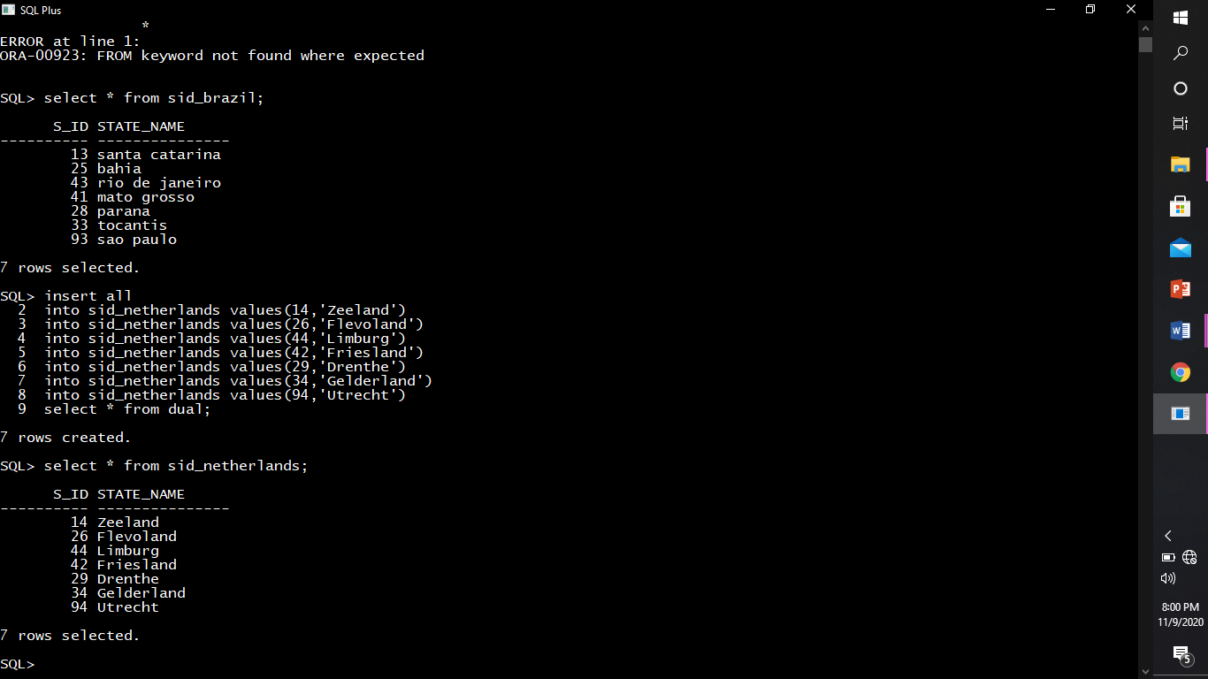

Creating table netherlands_states.

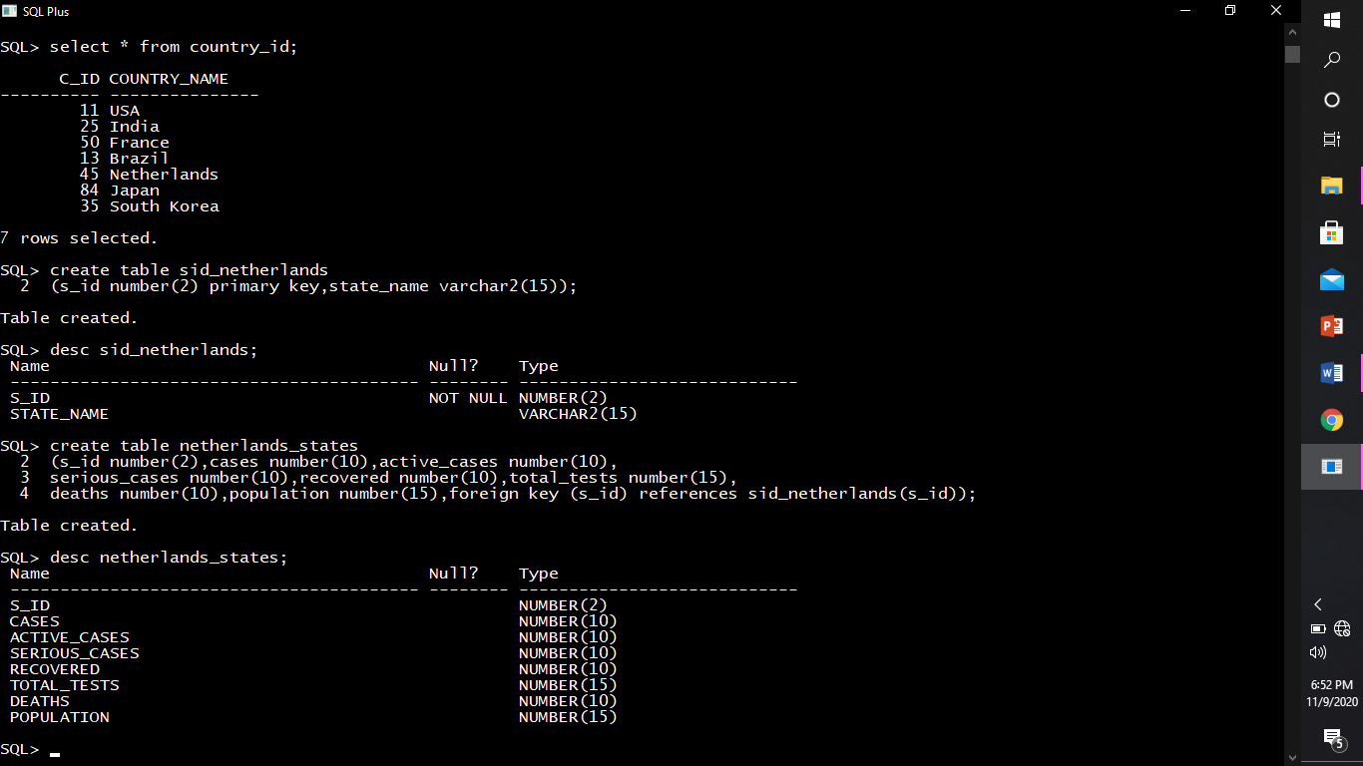

Describing structure of Netherlands_states.



Inserting rows into Netherlands_states.

